**Professional Skills**

**Training Intercultural Competence (TIC)**



Author: Ananya Madhur

Student No. 19069995

Programme: Communication and Multimedia (UX)

Lecturer: Jannie Oosting

**Professional Skills**



Client: Jannie Oosting

Author: Ananya Madhur

Student no. 19069995

Program: Communication and Multimedia (UX)

Lecturer: Jannie Oosting

City: The Haag

Date: 18.10.2019

No. version: 1

Table of Contents

Chapter 1: Introduction 4

Chapter 2: My Intercultural Biography 6

2.1 History about where my dad comes from 7

2.2 History about where my mom comes from 7

2.3 History about my brother and I 7

2.4 Culture 7

2.5 About my family 8

2.6 The D-date (which is moving to Netherlands 8

2.7 Conclusion 9

Chapter 3: My Communication Style 11

3.1 Communication and its different styles 11

3.2 Let’s find out what is my communication style 12

3.3 Conclusion 13

Chapter 4: My Intercultural Communication Barriers 14

4.1 About my barriers 14

4.2 Netherlands is my second home 14

4.3 Conclusion 15

Chapter 5: Intercultural Dimensions of Hofstede Applied on My Main Culture 16

5.1 Let me tell you about my country a bit more 16

Chapter 6: My Objectives and My Learning Goals 18

6.1 Let’s find out how intercultural competent am I? 18

6.2 My objectives 18

6.3 My SMART learning goal 18

Chapter 7: My Achievements 19

Chapter 8: Final conclusion 20

8.1 Introduction 20

8.2 Objective 20

8.3 Learning Goal 21

8.4 Am I feeling Intercultural Competent? 21

8.5 Further action plan 21

# **Chapter 1: Introduction**

I am Ananya Madhur from Mumbai, Maharashtra, India. I am 18 years old. I have lived in India for 18 years of my life and now have moved to the Netherlands to do my bachelors at The Hague University of Applied Science which is located in the Hague, Netherlands, Europe.

Before choosing this, I was very sure that I wanted to do something different than my friends back home, I didn’t want to study “Computer Science”/”Accountancy”/ “BA in arts” etc. Also, I don’t like much of theory, I love doing something which is more practical. That’s when I started to look at universities abroad and hence I ended up at the Hague University of Applied Sciences studying User Experience, which is also known as Communication and Multimedia.

In the course, I have a module named Professional Skills, wherein we learn about Intercultural Sensitivity. The question which might pop up, is ‘What is Intercultural Sensitivity’? This question will be answered in the following chapters.

The question which comes up is why do we study this? We study this particular subject because after I finish my graduation, I’ll be working in a company or setting up my own. So to understand their work environment, and also understanding people and their behaviour will take time but eventually that will happen. I will be able to understand others’ behaviour, or at least be able to understand their way of communication, because I engaged with this subject during my graduation. Hence, we study this module.

In this portfolio, I will be writing a total of 8 chapters. After the Introduction section, the remaining 7 chapters are: My Intercultural Biography, My Communication Style, My Intercultural Communication Barriers, Intercultural Dimensions of Hofstede Applied in My Main Culture, My Objectives and Learning Goals, Achievements and Conclusion.

In the above mentioned chapters, I will be writing about myself and how do I relate to it or how does my country or culture relate to it.

The objective of this portfolio is basically to know more about yourself, to discover more things about you, introspect yourself or your country or your culture and also to see how intercultural competent are you? If you are or not.

The readers of this report will be my client, lecturer, my buddy and myself.

Let’s go on a journey wherein I’ll share stories about myself, my culture and my country.

# **Chapter 2: My Intercultural Biography**

Intercultural sounds a bit heavy, to understand it better we’ll split the word into two: “inter” which means two different groups and “culture” which means customs, society, tradition etc. Hence, when we sum up these two words, it means customs, tradition in two different groups. In other words, intercultural means something that occurs between people of different cultures.

Let’s go through my life…

## 2.1 History about where my dad comes from

If I start talking about myself and my country, if someone asks where I’m from, the answer can rarely be expressed in one word. This is because, my father is from the south of India from a province called Tamil Nadu. However, he was raised in Shimla which is in the northern region of India. He did his schooling and attended college in Delhi which is the Capital of India.

## 2.2 History about where my mom comes from

My mother is from the east of India from province called Bengal. However, she was raised in Delhi. She did her schooling and attended college in Delhi. My mother and father went to the same college and that where they met and now are married.

## 2.3 History about my brother and I

My brother and I were born in Gujarat, in western India but were partly raised in Mumbai and Andhra Pradesh. The age difference which we have is 7 years . I have done my schooling entirely in Mumbai, whereas my brother had to change a lot schools since my dad was being transferred from one state to the other.

## 2.4 Culture

Although it may seem these are simply different provinces, the truth is that they have vast cultural differences in just about every aspect of life, whether it is music, clothes, food, and language. As a kid, I grew up in such a mixed household, I deeply believe that diversity enriches our lives.

In my country, every state and region has its own culture for example I mostly grew up in Mumbai which is in the centre area of India but if I compare my aunt who lives in the south of India (Chennai) there is a vast difference between both of us.

The differences are like, Chennai is a conservative city and relatively traditional whereas Mumbai is very open minded and not so conservative. One more difference is that Mumbai is a city which “NEVER SLEEPS”, whereas Chennai closes down at around 10pm.

My family is Hindu, but my mom and dad don’t follow any religious practices and also didn’t teach my brother and me so we don’t follow any particular religion. But when it comes to culture, the culture of many states (provinces) of India have influenced me, so there is no single culture which is my ‘main’ culture. People often ask what is my culture, what is my caste, where is my ‘village’. I’ve asked all these over and over to my parents and every time they hear me asking them this, they’ll tell me to say that “I am an Indian”, I say that “I am an Indian” because of the cultural diversity in my background being “Indian” also has many meanings. In other words, when you say you are Indian, it is already an acknowledgement of the diversity in your cultural background.

## 2.5 About my family

In my family, since we all are born and brought up in different regions of India, we all have different taste in music, games also we don’t follow a particular culture. We, as a family, are quite open about everything and get adapted to places in the world.

For example, If I was from a “typical” Indian family then I would have had to do what my parents decided for me. I wouldn’t have had a voice for myself. However, that’s not the case in my family, I can make my voice heard in my family, and give opinions about things.

## 2.6 The D-date (which is moving to Netherlands)

I moved to the Netherlands on August 18th 2019, when I arrived into the country, I had some expectations, thoughts, perception, judgments. Some of them seem true but some didn’t. For example, I had heard that people in the Netherlands are very direct, fitness freaks, kind - all these seem true. However, when I was back home when we used to sit for lunch in school, we all used to share our food. Here people eat what they’ve got by themselves, that’s a bit odd for me but I am adjusting to it slowly.

There are many cultural differences and some things are a shock for me till date. For example people here drink water from the taps whereas back home we only drank purified water. I have to live in the Netherlands for 3 years or more so if I don’t challenge myself enough or learn about their culture then overcoming the shock will never take place. Overcoming the cultural difference wouldn’t take place in just a minute, it may take few days/months or years depending upon how I adjust to the surroundings.

My family was very scared to send me here because I am only 18, and have never lived without my family for a long duration. However, they were sure about me adjusting in a new surrounding because I can adjust really quick, though a bit scared of whether I can take care of myself or not. They wanted to send me abroad for me to learn new skills, learn how to live alone, learn to be independent, learn to be a better person etc.

## 2.7 Conclusion

To conclude, for me intercultural competence means to have some knowledge about different parts of the world, accept them as they are, learn about their culture. My long term goal for myself would be to have a better understanding about Netherlands and then compare my country to theirs and see if there is anything common in terms of culture, food and people.



(Figure 1; My family)

# **Chapter 3: My Communication Style**

I’ll start by discussing some basics, such as, ‘what is communication’ and what the different styles of communication are.

## 3.1 Communication and its different styles

Communication is a process of sending and receiving messages.[1] In other words, a process by which information is exchanged between individuals through a common system of symbols, signs, or behaviour.

The different styles of communication are high context and low context. According to Lewis, My country is from a high context communication.

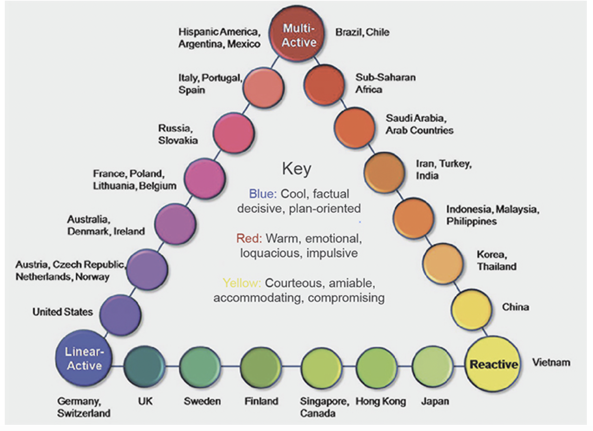(Figure 2; Lewis Model)[2]

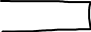

In high context communication countries, people communicate in an indirect manner. For example: India, Indonesia, Morocco etc. People start with the context, and then circle towards the main point, sometimes alternating between the detailed information and the main point.

In low context communication countries, people communicate in a direct manner. For example: Australia, New Zealand, North American etc. They start with the main point, and then moves on to details.

## 3.2 Let’s find out what is my communication style

I come from an high context community, it is difficult for me to switch immediately to a low context community. India is a high context community, you will find Indians “beating around the bush” - which means not getting on to the point.

In my culture, when people say something directly it is shocking for us, because we normally never speak of things directly. In Hindi, there is a phrase called “Ghuma Phirake”, which means ‘beating around the bush’.

When I talk about my style of communication, right though our elementary school the values of having a charming personality, was ordained on us. However, never was much emphasis given on the style of communication one perceives through the course.

From the word “go”, I always had a urge to express myself and state out my opinions and thoughts on any matter in hand. The thought of following a single lineage towards matter never had my compliance, rather an open discussion on topics ranging from one’s emotions to work held more relevance. I would peg myself to be the assertive type of communicator being emotionally and socially expressive and making my own choice on the what and owning up to it.

Also, I have a subtle type of communication, I don’t often start a conversation, but when its going on, I mostly listen and add any points I think are relevant. I always listen to understand and not just reply. I have a bit of an inquisitive communicative nature, I tend to ask some really valid questions. All in all, I communicate really well with people I know, but take time to open up with people I have just met.

## 3.3 Conclusion

To conclude, in this chapter, I have spoken about what is communication, the different styles of communication and what is my style of communication. I am from India, my country we have high context communication, which means that we communicate indirectly. By the word ‘indirect’, I mean that we don’t get to the main point first.

As we know, that there are broadly two type of communication styles - high and low. They both have their advantages and their disadvantages.

I mentioned earlier that I am from India and we have a high context communication style, for me personally I have a subtle type of communication which means, I don’t start conversation but when its going I tend to listen.

I have shifted to the Netherlands for my graduation, here the style of communication is low context, which means that the people here get to the point first. In a way it is easy because you get to the main point first and later talk about rest.

Coming from a high context country, it will be difficult at first to communicate in a low context style. However, I will need to switch my style of communication depending upon the situation. For example, if there an emergency I will need to speak in a low context style because it’s an emergency.

# **Chapter 4: My Intercultural Communication Barriers**

In the class on Intercultural Communication Barriers, we were shown videos and asked to reflect upon ourselves and how we behave in different situations. This lesson for me was personally very relatable because in India I have been body shamed, bullied for my skin tone etc.

## 4.1 About my barriers

In India, dark skin tone is usually not accepted, by the word “accepted” I mean it’s not encouraged and rather discriminated against. When I was in school, I was bullied for my skin tone and called names such as crow, ugly etc. Whenever I used to go to buy my cosmetics, people at the shop would tell me that my face is tanned or I need a fairness cream which certainly I don’t. This sent a signal to me that I wasn’t accepted within the friends’ circle or even in the society, nor was I respected. As a result, I have always been apprehensive of being judged adversely.

We generally overcome anything by understanding the situation/ reading about them or putting ourselves in their situation and then reflect. The limitation which I have within myself is that I can’t express myself fully, by this I mean I am scared to express myself because I feel I am judged by the society or I may not fit into the society like others do. To overcome such a position I try to express to the ones who I know wouldn’t judge me, the ones who I trust.

## 4.2 Netherlands is my second home

When I decided to come to the Netherlands, the first thing my parents told me is that in this country you can be who you are, you don’t have to be someone who you aren’t. On my first day in college, I didn’t feel that I was being judged. My class is like my second home which means I trust the people who are in my class and also do care for them.

One more example is I had gone for an job interview in this Indian restaurant and I also had to take an interview of the manager for my college research. I went to the restaurant cycling and I wore a cap to cover my ears. When I was leaving the restaurant, I took my cap out and started wearing it. I heard someone saying that it’s not so cold, I said sorry because I didn’t know whether he was talking to me or not. He again said the same thing it’s not cold, I wondered why is he giving his opinion. However, I didn’t say anything and went on. This experience was strange. My parents have told me not to talk to strangers and I guess that applies anywhere you go. When this guy told me this I was scared and I didn’t know how to act in such a situation because I haven’t encountered anything like this before in my life.

## 4.3 Conclusion

To conclude, one barrier that I face is to openly express emotions, ideas, opinions in normal communication. However, sometimes I feel that music helps me to express myself better. Music is like a powerful tool in my life because it calms me down if I am angry or upset.

Usually, people say that talking to others helps. I have tried that, it does help but sometimes it fails to help me. To overcome this barrier, I will try to share my emotions/thoughts/opinion with others without the feeling of fear within me. At first, I could start with my friends and family, then move on to my classmates, and finally the gigantic world.

# **Chapter 5: Intercultural Dimensions of Hofstede Applied on My Main Culture**

Geert Hofstede is a Dutch organizational psychologist who enjoys international fame in the field of intercultural studies.[3] Hofstede created 6 dimensions which are:

* Power Distance Index
* Masculinity and Femininity
* Individualism and Collectivism
* Uncertainty Avoidance
* Long Term Orientation
* Indulgence and Restraint

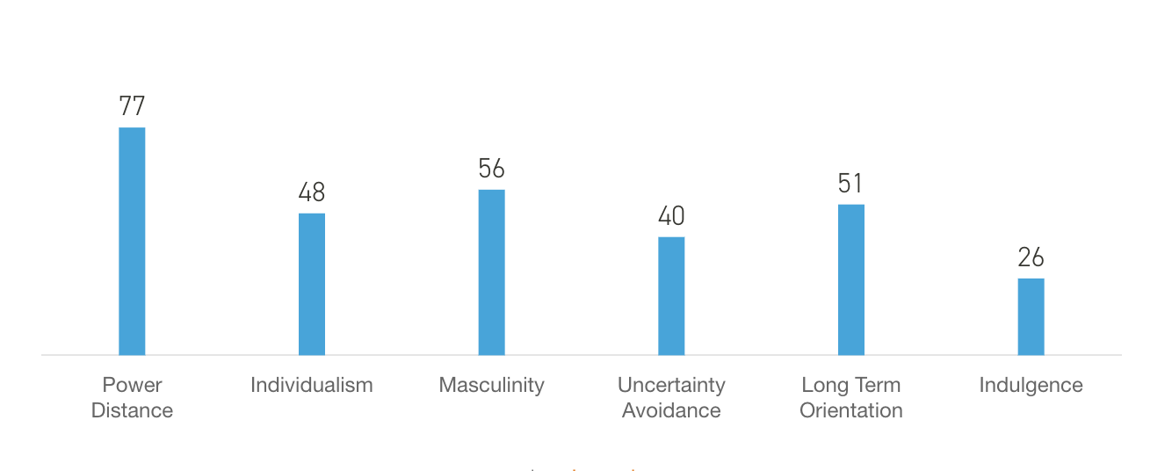(Figure 3; Hofstede’s Dimensions)[4]

## 5.1 Let me tell you about my country a bit more

1. Power Distance Index:

I would say, in my country we have a hierarchy in companies which means if my boss says something to me I ought to follow that and if I don’t I might get fired.

1. Masculinity and Femininity

I would say my country would be more masculine. I say this because in my country everything is about competition, for getting into a college or school we need to compete. People compete being in classrooms. People compete for being a teacher’s pet etc.

1. Individualism and Collectivism

I would say my country is more towards collectivism but also has individualism. Collectivism comes into play when people live in a joint family and it’s decision making time. Individualism will come into play when people live in nuclear family or live alone.

1. Uncertainty Avoidance

I would say people in my country do the impossible things as well because they find solutions for everything. People in India use alternative solutions for unexpected solutions. In Hindi, there is a saying called “jugaad” which means finding alternative solution. Generally, people in India are not comfortable with dealing with uncertainty, they try to adjust in whatever situation they are in.

1. Long Term Orientation

In my country, ‘*karma*’ dominates religious and philosophical thought, people are more inclined to long term. In India there is an acceptance that there are many truths and often depends on the seeker. Societies that have a high score on pragmatism typically forgive a lack of punctuality, a changing game-plan based on changing reality and a general comfort with discovering the fated path as one goes along rather than playing to an exact plan.[5]

1. Indulgence and Restraint

I feel my country is restraint because I have seen my friends who aren’t allowed to do things like other people. For example I have a friend who has to go back at 7.30 pm back to her house otherwise she’ll get a scolding.

# **Chapter 6: My Objectives and My Learning Goals**

## 6.1 Let’s find out how interculturally competent am I?

Coming from a country of multiple languages and cultures, I believe I have a natural inclination to intercultural competence. However, it does take time to adjust to a new country and culture. Keeping some specific objectives in mind can help in achieving this faster.

## 6.2 My objectives

My objectives for the time being is to get adjusted to this whole new country and its ethos, get accustomed to this new way of teaching and doing assignments, and taking care of my health.

## 6.3 My SMART learning goal

My SMART formulated learning goal is ….. before I tell you my learning goal, I’ll tell you the full form of SMART. SMART stands for Specific, Measurable, Attainable, Relevant and Time-bound.

Now, my learning goal is to learn some sentences in Dutch which describes me. I find it SMART because I am specific about my sentences, and measurable because I can ask or speak these sentences out and see if people understand. It is attainable as I kept it realistic - if I said that I wanted to be a fluent Dutch speaker in 6 weeks that’s not quite possible. It is relevant because then I can speak such sentences of my classmates and my teachers, which would ultimately help me in adjusting better. And lastly, it is time-bound. I’ll be able to achieve my learning goal by the presentation date, because I need to practice saying the sentences and I should be fluent.

**6.4 My buddy and her feedback**

My buddy is Chiiini from Austria, I haven’t discussed my learning goal with her. However, I have discussed my learning goal with Jannie who is my teacher. Regarding the feedback, I have uploaded screenshots of the changes she has asked me to take into consideration (Appendix 4, attachments). Overall, she said that I was on the right track with my assignment.

# **Chapter 7: My Achievements**

When I came to the Netherlands, I thought I would probably return to India in a month or so because this is my first time living outside my country, staying away from my parents, being independent in everything I do. When I was back home, I never had to cook my own food or wash my own clothes, never felt that I was alone. However, when I moved out I had to do everything on my own from cooking, washing my own clothes, and most importantly, adjust to a new place and culture and make my own decisions every single day. I have also had to learn to get by on my own in a new place where I am still unfamiliar with the language. Considering everything, I think I have travelled a great distance in these past few weeks.

As for my objectives which I stated in the previous chapter, I am still working on everything. It isn’t easy for me to adjust to the educational system because it’s quite different. For instance, in my school we couldn’t disagree with our teacher even if we wanted to. There was a line between the teacher and the student, teachers were not so accessible like here. These are all minute details but it matters a lot when you are used to thinking in one particular way and then come to a place where things are done so very differently.

As for my learning goal, it’s in progress, I have asked one of my classmates to help me out with my learning goal. She teaches me Dutch, we sit together after every class and teaches me how to pronounce and say the sentences in Dutch. The first few days were really tough because Dutch is totally different from the languages I know and therefore a bit difficult. However, I will try my best to be a perfect in speaking those sentences by the day of presentation.

# **Chapter 8: Final conclusion**

In this portfolio, there are 8 chapters that give a glimpse of my life’s journey so far. They are: Introduction, My Intercultural Biography, My Communication Style, My Intercultural Communication Barriers, Intercultural Dimensions of Hofstede Applied in My Main Culture, My Objectives and Learning Goals, Achievements, and Conclusion.

In this concluding section, I will try to summarise the other sections and sketch out a brief plan for the future.

## 8.1 Introduction

I am Ananya Madhur from Mumbai, Maharashtra, India. I have moved to The Hague, Netherlands for my Bachelors’ degree. I have lived in India for 18 years of my life and now have moved to the Netherlands on 18th August, 2019. I was clear that I didn’t want to study the “popular subjects”, plus I didn’t want to much theory. Hence I started to look for universities abroad and ended up at the Hague University of Applied Sciences.

At first, I was super scared, apprehensive whether I’ll be able to manage everything on my own because it was my first time moving away from home for 3 long years. However, I don’t regret taking this decision. I say so because every day and everything is a challenge for me, back home I always used to demotivate myself saying that “ I can’t do it” but now I say “ I will do it” and move on.

## 8.2 Objective

The objective of this portfolio was to discuss how Interculturally Competent I was. Where I stand now and how far did I come in these 8 weeks. This portfolio has helped me a lot, it made me realise the things I have done in the past, it made me realise many aspects about myself that were buried deep inside, it made me discover myself all over again. It also made me question, do I even know my own country well enough?

## 8.3 Learning Goal

My learning goal of being able to speak some sentences in Dutch is still in the process. I am still working on it, because I need a lot of practice for it. However, I am pretty sure that I will be able to speak these sentences in Dutch by the presentation time.

## 8.4 Am I feeling Interculturally Competent?

I would answer this specific question in a different way. I would say that I always felt Interculturally Competent, I say this because India as a country is vast, every region has its own culture so growing up in India has already equipped me with some degree of intercultural competence. Still, I wouldn’t say that I am a 100% interculturally competent person. I always welcome new things and culture, and although sometimes some things are hugely different from what I am used to, I try to adapt to the situation rather than being rigid and judgemental. Overall, I would say that I am confident and am half way there. Half way to being a completely interculturally competent person.

## 8.5 Further action plan

My objective in life is to understand different cultures and adapt to the Netherlands culture, their food, their style of doing work, or even living life. I would love to formally learn their language as well, which is Dutch. By writing this portfolio, I have come to know about many different ideas and frameworks which will help me during my work life and perhaps even my internship.

**Attachments**

Appendix 1- Handout self-reflection

Appendix 2 – Handout (low vs high)





Appendix 3 – Personal DNA



Appendix 4: Feedback from Buddy

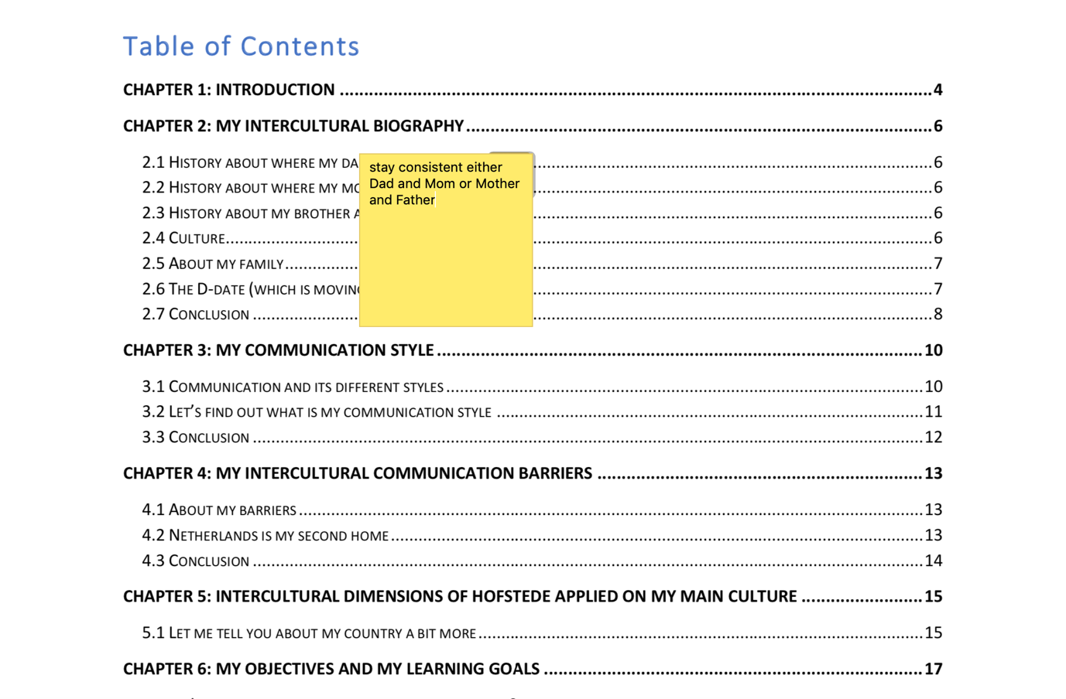

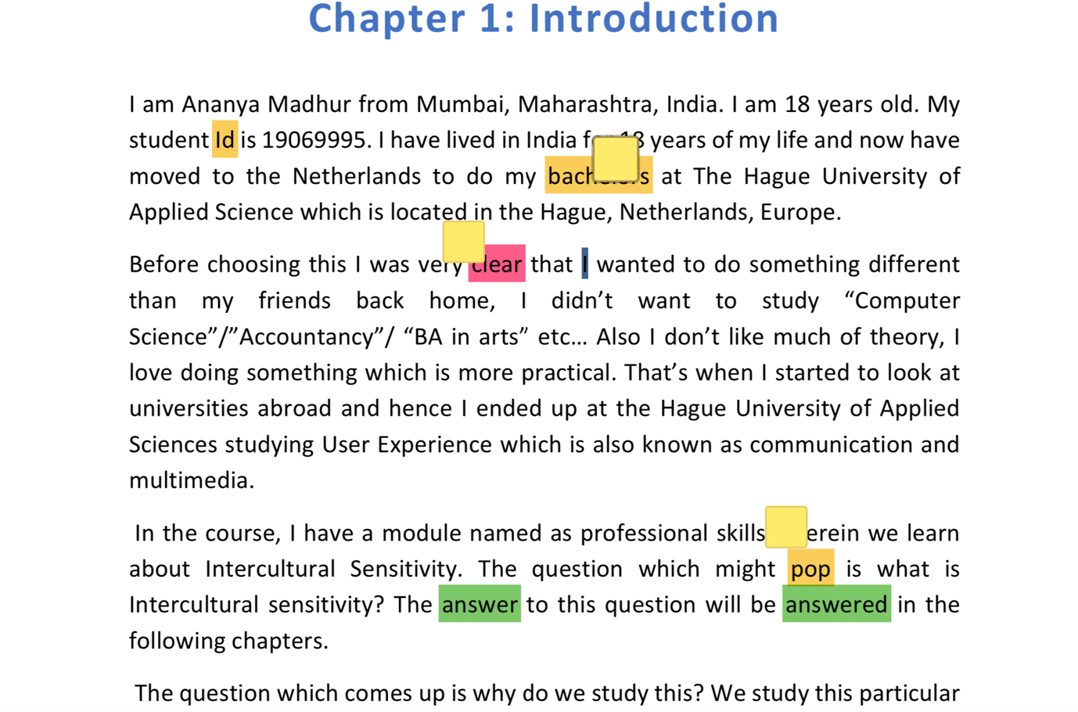

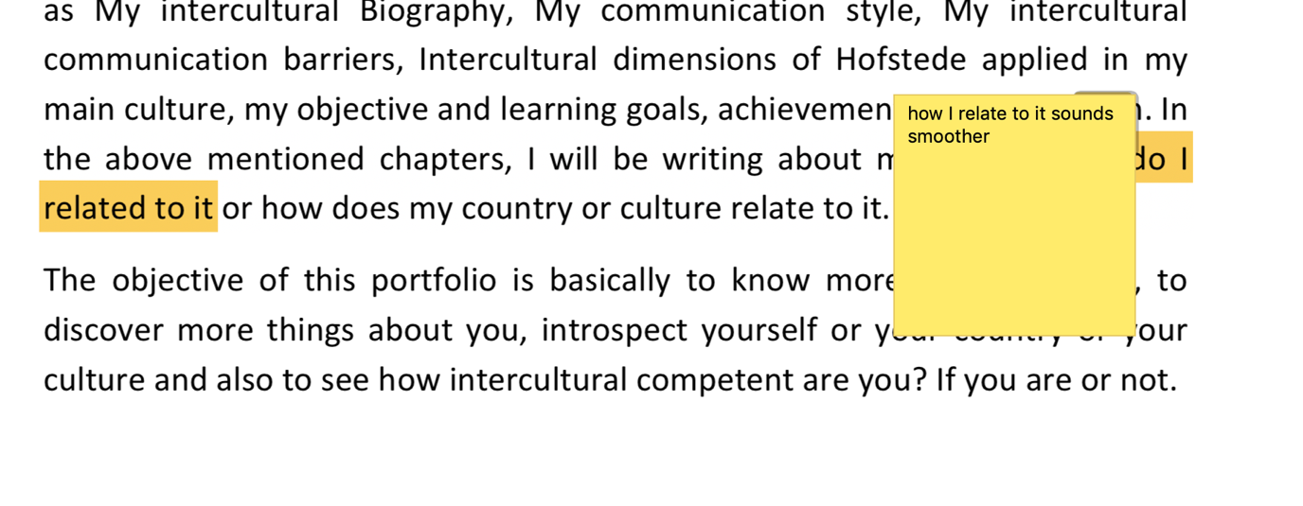

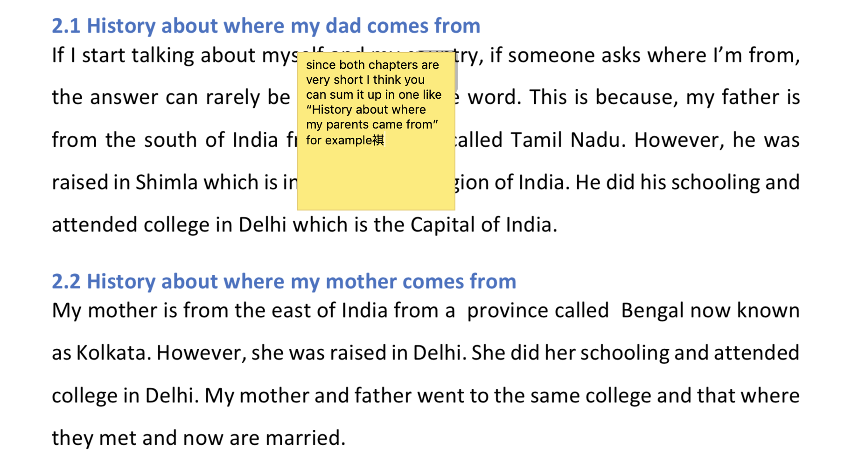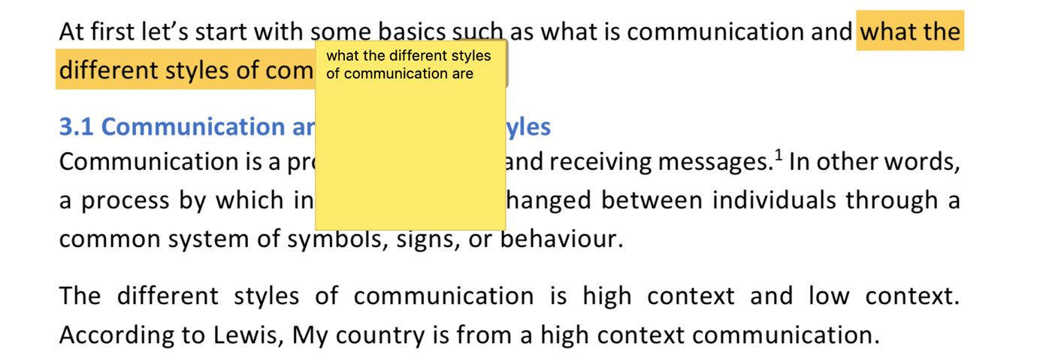

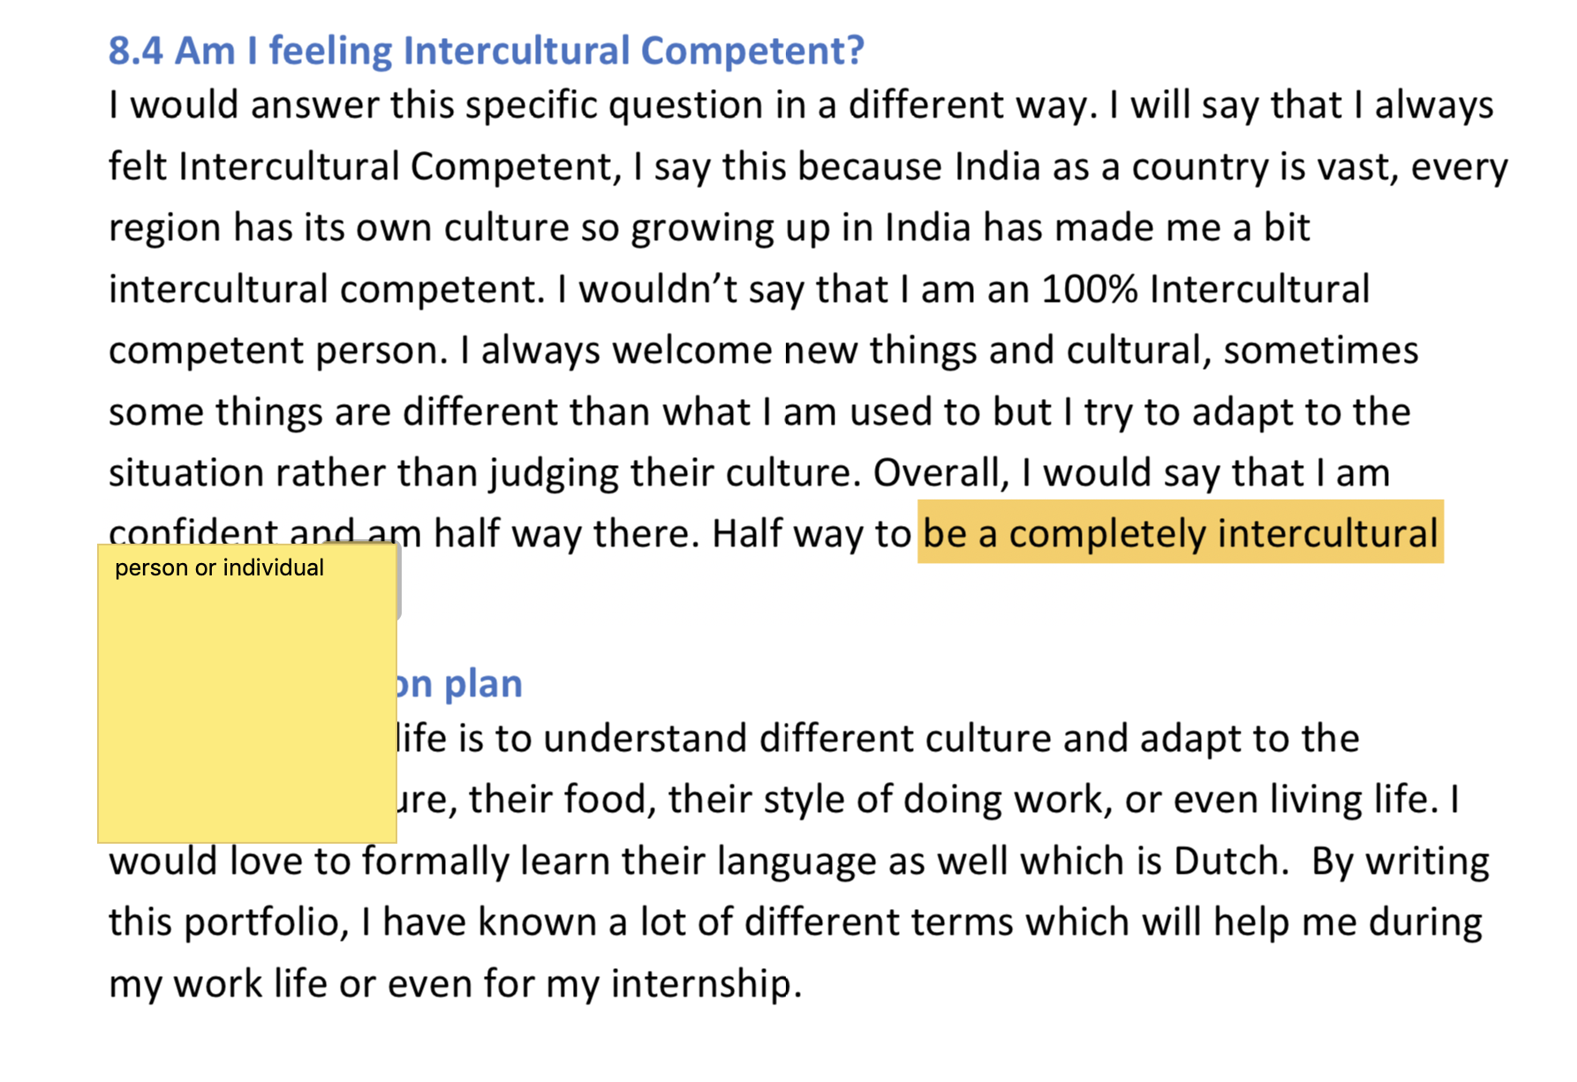

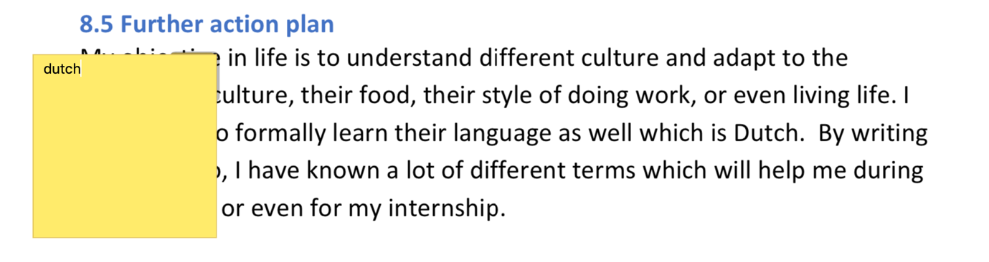

1. Google.com
2. Jannie Oosting presentation
3. <https://en.wikipedia.org/wiki/Hofstede%27s_cultural_dimensions_theory>
4. <https://www.hofstede-insights.com/product/compare-countries/>
5. <https://www.hofstede-insights.com/country-comparison/india/>